Ruskin House School

banner with apples and crayons

Newsletter

November 2020

# C:\Users\Staff\Pictures\Camera Roll\2020-11\IMG_2697.JPG

# This Month Toddler Room will be introducing Math’s concepts in everyday play

**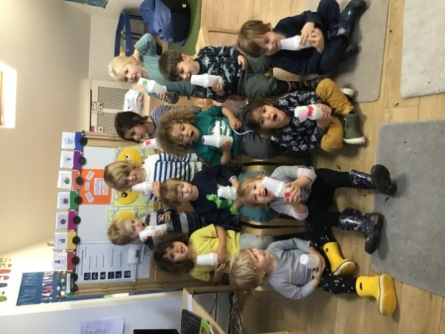**

Pre-school

November will be discussing sounds and making musical instruments

# C:\Users\Staff\Downloads\20201014_135926.jpg C:\Users\Staff\Pictures\Camera Roll\2020-10\IMG_1907.JPG

## Update of Staff deployment which will take place over coming weeks

**Baby Room** – Kim, Alison, Nikki and Fatma and Jodie

**Toddler Room** – Caroline, Charmaine, Chris, Paula and Merlin.

**Pre-school –** Avril and Maria, Lucia

## Did You Know!

## Interesting facts about winter.

## Winter is the coldest season of the year, falling between [autumn](https://www.bing.com/search?q=Autumn&filters=sid%3ab0d8174f-16c7-60d5-2531-601ff8966217&form=ENTLNK) and spring. The date of the beginning of winter varies according to climate, tradition and culture, but when it is winter in the [Northern Hemisphere](https://www.bing.com/search?q=Northern+Hemisphere&filters=sid%3a5bee00ac-1f8e-3f8a-7aa9-a5b2421ea562&form=ENTLNK), it is summer in the [Southern Hemisphere](https://www.bing.com/search?q=Southern+Hemisphere&filters=sid%3a5c726072-b24a-29a6-1085-eee559e1ce70&form=ENTLNK), and vice versa.

## Every winter, more than a septillion snowflakes fall down to Earth, according to the Library of Congress. To put it another way, that's 1,000,000,000,000,000,000,000,000 snowflakes or a trillion trillion.

Due to the change of temperature we are asking all parents to provide their child/ children with suitable clothing such as, an all-weather coat, hat, and gloves. Please remember to label all your child’s clothing

# 

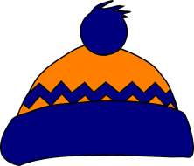

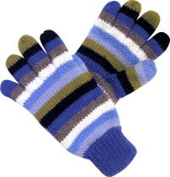

#### Our Theme for November

Shades of Colours

**Using our five Senses to start the celebration of a virtual 12 days of Christmas**

###### Fun quiz for parents.

**(Answer from previous Month )**

 What were Jack Lanterns carved from before pumpkins were used? **Turnip**

 What is the day after Halloween called? **All saints Eve**

In what year will the next full Moon occur during 31st Oct ‘Halloween’? **2020**

**This Month Questions**

Which is highest mountain in the UK?

How many Children did Queen Victoria have?

Which King did Guy Fawkes attempt to kill?

(**Answers next Month )**