April Newsletter 2019
Ruskin House School

Upcoming Event
Easter Hat parade
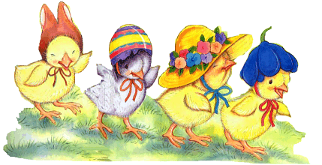
Thursday 18 April 2019
on this day children can dress up in their favorite costume


The months of April through to August are filled with amazing activities thanks to holidays such as Easter parade, Father Day, Preschool Graduation and especially the warmer weather.
Our main objective is to continually improve and perfect your child’s skills and techniques in areas such as, problem-solving, investigating and critical thinking
We are looking forward to a wonderful ‘Summer’ with y0u and your children, we do have lots of lovely things planned.

Easter Parade
Are you Creative?
We will be celebrating Easter by having an Easter Hat parade. Therefore, your child will need your support to create an Easter bonnet. The parade will take place on Thursday 18th April 2019
Reminder
We are closed for the following dates for Easter Friday 19th and Monday 22nd April 2019.

New Starter
RHS extends a special welcome to all new children and parents who have started with us in the last couple of weeks. The team and I do hope that your time with us will be enjoyable. If you do have any concerns or questions, please don’t hesitate to talk to us.

Mud Kitchen
We are still developing our garden to enhance the quality of children’s learning. On this note we need your support, therefore, if you have any unwanted cooking utensils such as sauce pans, spoons, items for pouring including metal objects we would love to have those too.
This request will enlighten, motivate and give your child the opportunity to use their imagination and creativity

Autumn Room
Autumn Room will be holding parent meeting in April



